Initial post

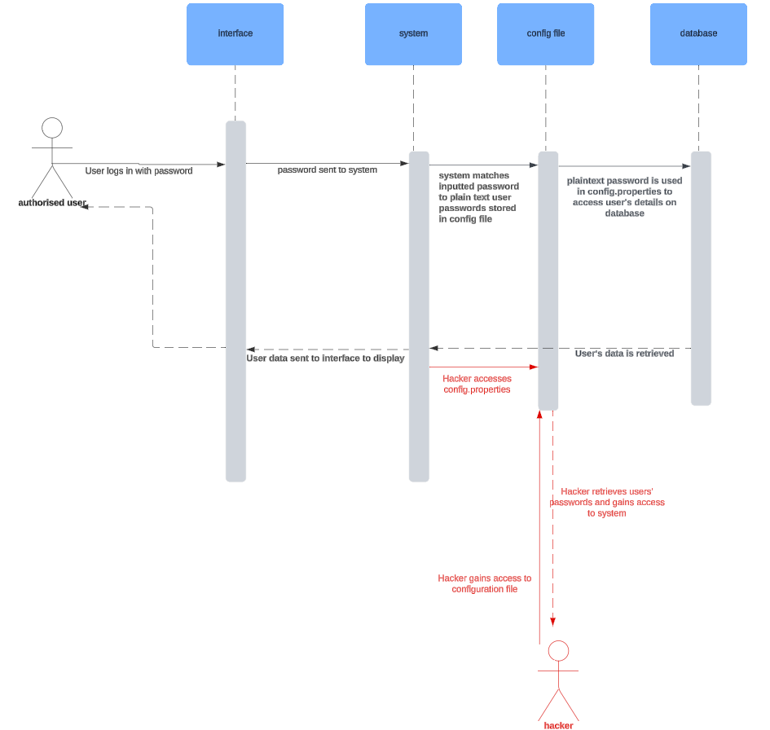
Plaintext password storage is a security weakness categorised as ‘Broken Authentication’ (CWE, 2017). It involves the storage of users’ passwords as plaintext, as opposed to encrypted data, and is commonly saved in a configuration (config) file (CWE, 2017). The stored plaintext passwords are directly matched to a user’s inputted password before being used to access their relevant data in the connected database (CWE, 2017). Through using this method of password storage, developers can enable cybercriminals to gain easy access to users’ passwords, which will then grant access to the entire system (CWE, 2017). As a result of such an attack, such attackers have been able to change how software operates, enabling further damage such as denial of service attacks and changing executed code; this can cause huge safety implications, depending on the industry that employs the software (CWE, 2017). In order to protect against this, it is advised that passwords are not stored as plaintext or cleartext, but are instead encrypted (CWE, 2017).

To present the design of my group’s proposed software, I think that class diagrams will be most useful as they show the relationship between classes, their attributes and methods i.e. the underlying structure of an application (Object Management Group. (2017). This will then directly inform the implementation of the code used within the application.

References

Object Management Group. (2017) Unified Modeling Language (UML) Specification Version 2.5.1. Available from: https://www.omg.org/spec/UML/2.5.1/PDF [Accessed 5 August 2024].

OWASP Foundation. (2017) OWASP Top 10. Available from: https://owasp.org/www-project-top-ten/ [Accessed 4 August 2024].

